Snake can be controlled with up/down/left/right

There are 2 food items at any time, these are replaced 1:1 as eaten. I went this way to stay true to the original snake game, therefore they are all worth the same as well. When the player eats a piece of food the score will increment by **one**. When the player loses the final score is displayed

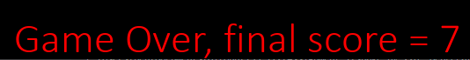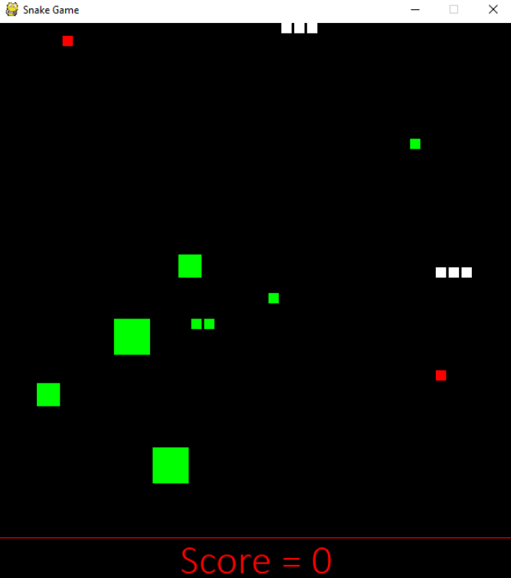

­­­___

8 GREEN Obstacles are placed around of various sizes, if the snake collides with this you will lose.

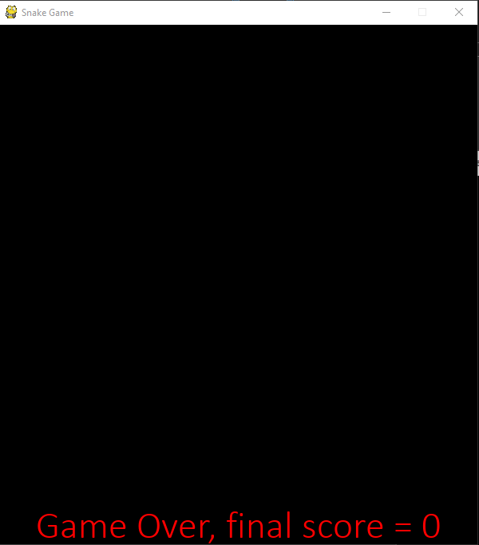

____

If the snake passes over (eats) a piece of RED food, it will grow in size by one block. The enemy snake will grow at the same rate as the player snake HOWEVER, while the AI snake does not actively seek out food, if it does encounter food it will eat it and grow in size by one, becoming larger than the player snake. (Notice AI snake (top) is one block larger than player snake)) This is quite rare.

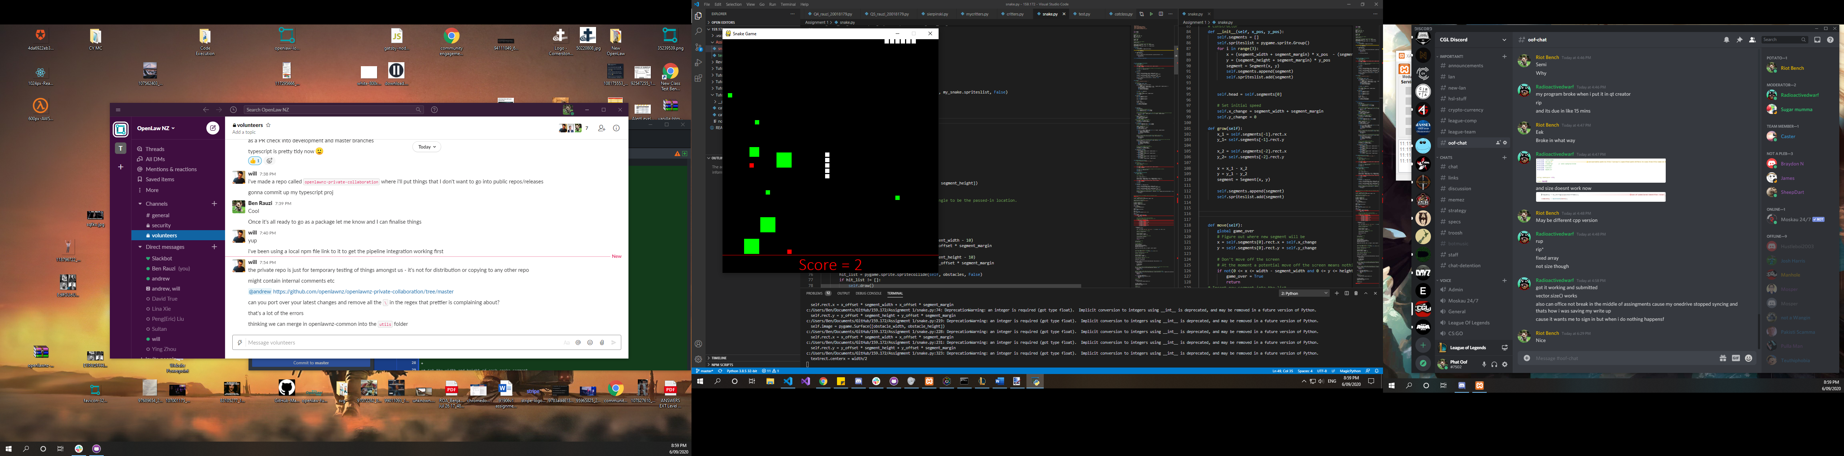

___

If the player hits the edge of the playing area (window borders or red line) they will lose (not screenshotted because there’s no way to prove this with a single frame, and two frames could just be doctored so what’s the point in annotating it…)



The AI snake will change direction randomly every **10** movements (this is not too often, but it is often enough to make the AI somewhat random), or any time that it encounters an obstacle such as the green obstacles OR the borders of the screen. The snake will change to a move in a random direction but will not double back on itself or run into any other obstacles in it’s change.

If the Enemy snake collides with any part of the player snake, or the player (head) collides with any part of the enemy snake, the player will lose. This can be especially hard when the snake is long as you cannot move your tail if the enemy snake is coming towards it.

Also notice that score is 5 and still 2 food items, so food is replenished.

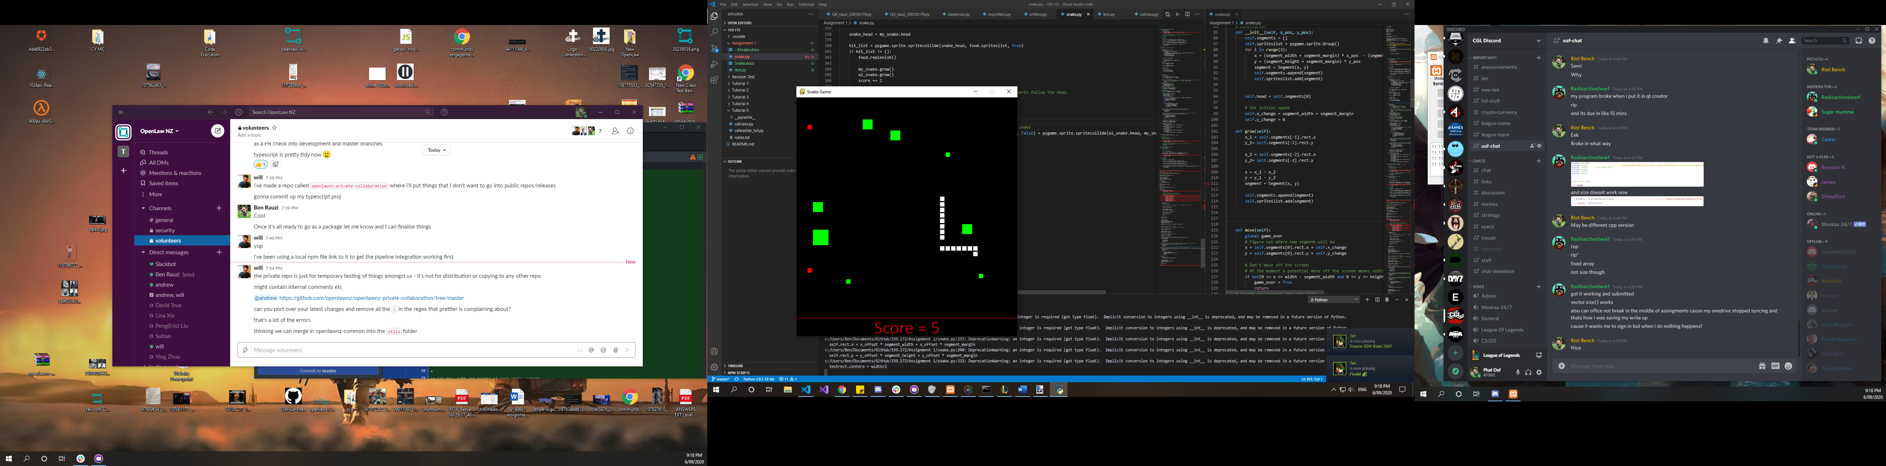

I also have not chosen to split this into multiple files, even though it may be good practice, as the instructions say to upload a single .py file.